**Exercise: Examine a web page**

**Introduction**

In this exercise, you will practice examining an HTML page using the developer tools.

**Goal**

* Inspect the HTML document using the developer tools in your browser.

**Objectives**

* Find the HTML ID of the Little Lemon logo.

**Instructions**

**Step 1:** Download the following file on your local system.

**Step 2:** Unzip the file.

On Windows, open your Downloads folder, right-click the file *examine_the_page.zip* and select Extract All.

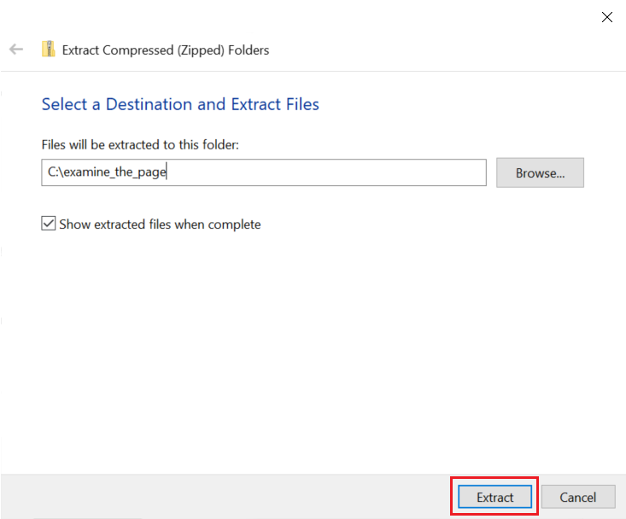

On Mac, open your Downloads folder and double click the file *examine_the_page.zip*.

Once unzipped, there will be a folder named *examine_the_page*.

**Step 3:** Open the folder and double click index.html to view the file in your local web browser. Verify that it looks like this:

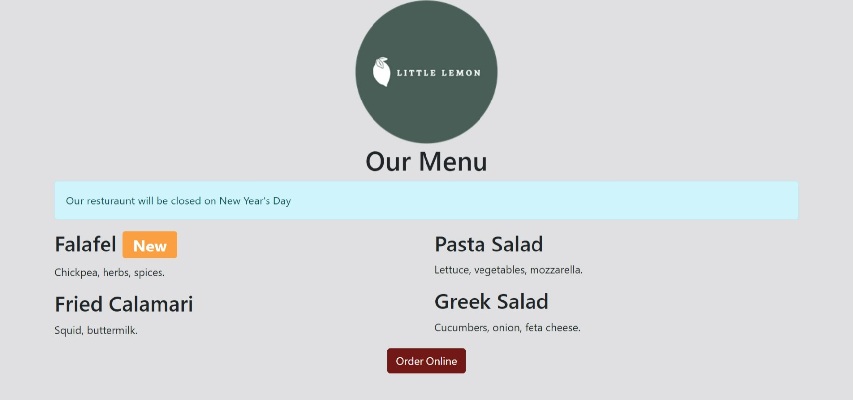

**Step 4:** Right-click the Little Lemon logo and select Inspect (or Inspect Element)

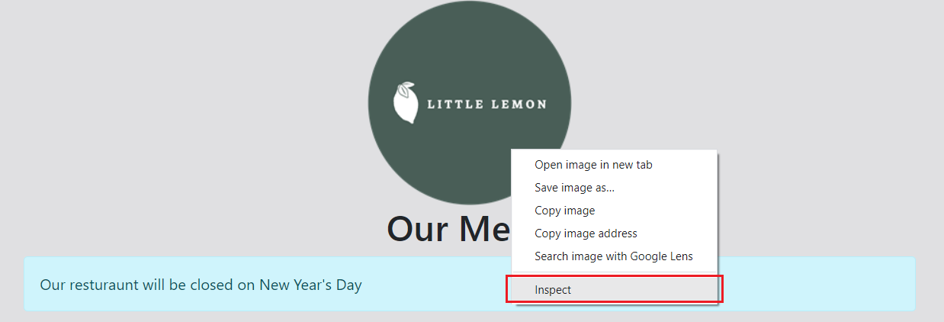

**Step 5:** Inspect the line in the HTML for the logo in the developer tools panel. The line begins with <img.

**Note:** In the line, there is an ID in the following format id="???". Note the value that the ID is equal to.

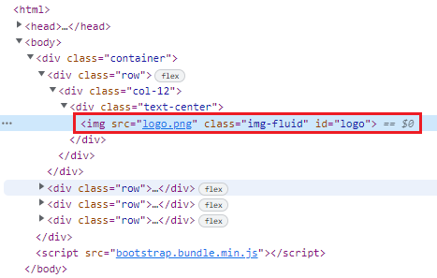

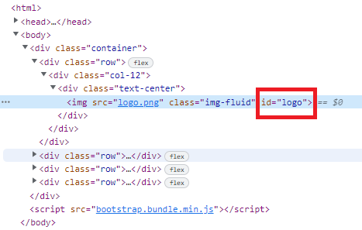

**Tips**

* If you get stuck, close the developer tools and start over.
* Review the lesson *Developer Tools*.